Week 6 – Intensive Writing Week  Daily Sprints | 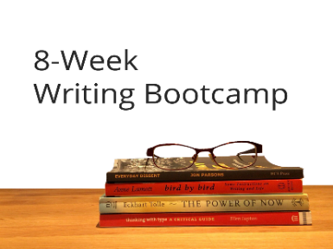
This week is our Intensive Writing week! Your task is to complete a “sprint” every day. A sprint is a focused burst of writing (~1,000 words) on a particular element of your book. Pick one writing topic from our list or come up with your own if you feel inspired! One way to approach this is to set your timer for 25 minutes, then take a 5-minute break. Repeat until you’re done the sprint (see Avoiding Overwhelm Trick #4 in the Week 5 resource). You got this. 😊

MONDAY – DAY 1

Write one of these elements: |  | Total Word Count
- the Introduction
- the Acknowledgements
- the Opening Hook to your novel
- whatever inspires you today

TUESDAY – DAY 2

Write one of these elements: |  | Total Word Count
- the How This Book Works section
- the first section of Ch. 1
- character sketches of your protagonist and antagonist (their flaws, what they want, and what they need)
- choose your own (adventure)

WEDNESDAY – DAY 3

Write one of these elements: |  | Total Word Count
- the section of Ch. 2 you’re most excited about
- the section of Ch. 2 you’re avoiding
- the climax of your book
- up to you

THURSDAY – DAY 4

Write one of these elements: |  | Total Word Count
- Ch. 3, any section
- a how-to section
- the Hero at the Mercy of the Villain scene (the key scene where the hero seems trapped!)
- the section you’re procrastinating doing

FRIDAY – DAY 5

Write one of these elements: |  | Total Word Count
- as much of Ch. 4 as you can. Go!
- find opening quotes for all your chapters
- any scenes from the middle build of your story (add in progressive complication!)
- up to you

SATURDAY – DAY 6

Write one of these elements: |  | Total Word Count
- choose any chapter from the second half and start writing
- your favourite section
- a section you’ve avoided since the beginning
- whatever calls to you

SUNDAY – DAY 7
Write one of these elements: |  | Total Word Count
- the conclusion
- the final scene (if you know it)
- pick a scene at random
- write two sections of your choice ’cause you’re on fire!

