Week 7 – Formatting, Beta Readers, & Editing | 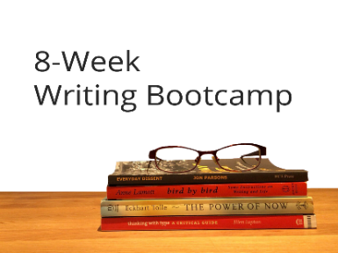
This week you got a behind-the-scenes look at what happens when your manuscript gets sent into a black hole to be edited. This resource will provide links to help you find beta readers and professional editors. You got this. 😊

Formatting checklist

Include front matter
Apply Heading 1 style to chapter titles
Apply Heading 2 style to any subheadings
Modify styles to suit your preferences
Add section breaks (next page) at the end of all chapters
Create an automatic Table of Contents
Insert page numbers in header or footer (chapter 1 starts on page 1)
Make sure front matter doesn’t have page numbers (in chapter 1 footer, uncheck ‘link to previous’)
Double space body text
Indent paragraphs (right click / Paragraph / Indentation first line 0.5 inches). Do not indent using tabs or spaces.

Where to find beta readers

- Go where writers hang out
  - Facebook groups (Beta Readers & Critiques)
  - Writing Forums (My Writers Circle // Absolute Write)
  - Writing Groups (Writers Carnival // Goodreads)

Where to find professional editors

- Editors Canada online directory
- Editorial Freelancers Association
- Society for Editors and Proofreaders
- Nonfiction Authors Association
- Alliance of Independent Authors
- Reedsy

Further reading:
- Erika’s blog post about types of editing

