Week 8 – Self-Publishing Checklist | 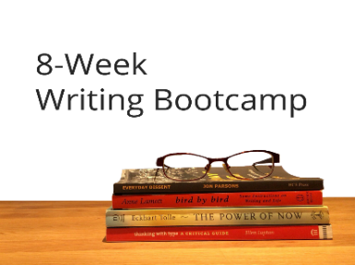
This week was a crash course in self-publishing. This checklist will help you get all your ducks in order as you approach the final stages of your self-publishing journey. You got this. 😊

Interior Text Files

- Write first draft
- Rounds of revisions and self-editing
- Hire editor for developmental and copyediting
- Format Word document (see File Creation Checklist)
- Hire proofreader for final pass
- Create PDF, EPub, and Mobi files

Book Cover

- Hire professional book cover designer from Book Design Templates, 99Designs, or Reedsy, etc.
  - Full front cover and thumbnail (as PDF, .jpg and .png)
  - Full cover spread (back cover, spine, front cover) for print books (see Amazon’s paperback cover template)
  - 3D version of your book for promotional purposes
- Write book blurb for online retailers
- Write back cover blurb

ISBNs

- Decide on self-publishing name (will need this to create your ISBN account).
- In Canada, create an ISBN account with Library and Archives Canada.
- Get a separate ISBN for each format of your book (print, EPub, Mobi, etc.)
- Give yourself up to 10 business days to gain access to your account.

Upload Files to Online Stores

- Amazon’s Kindle Direct Publishing (KDP)
  - Upload separate cover (full spread for print & cover image for ebook)
  - Print PDF (for print-on-demand physical books)
  - Mobi file for ebooks
- IngramSpark
  - Upload PDF cover file and PDF interior (for print)
  - Upload EPub file for ebook and front cover (jpg file)
- Barnes & Noble (B&N)
  - Upload cover, EPub file to B&N Press
- Apple iBooks
  - Upload your EPub file and front cover
- Kobo
  - Upload your EPub file and front cover
- Smashwords
  - Follow their style guide carefully before uploading new EPub file
- Further reading on print-on-demand: https://blog.reedsy.com/print-on-demand-books/

Market and Sell Your Book

- Start an author website or blog (WordPress, Weebly, PubSite are good)
- Make an Author Facebook page (and other social media of choice)
- Start growing a mailing list (Mailchimp is a good start)
- Pre-order campaign on Amazon
- Consider offering a permafree book as a reader magnet
- Use reader magnets in your book’s backmatter to funnel them to your website
- Use BookFunnel to easily deliver copies of your book in various formats

