Week 8 – Course Evaluation | 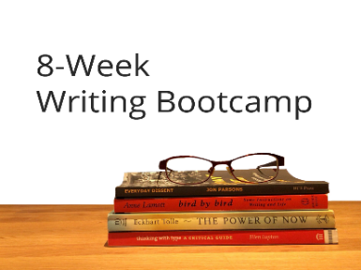
Your feedback on the course is extremely important to us. Please take a few minutes to give us your candid appraisal of the course and ways we may improve.

On a scale of 1 to 10 (1 being not at all and 10 being absolutely), answer the following questions about the 8-Week Writing Bootcamp.

- I felt supported throughout this course: _____

- The 1-on-1 coaching calls helped keep me on track: _____

- The developmental feedback from the instructor was valuable: _____

- The course video lessons were clear and easy to follow: _____

- The course video lessons gave me valuable skills and info: _____

- The course worksheets were useful: _____

What did you like or dislike about the course learning management system (Thinkific)?

Do you have any specific feedback about the course instruction?

Do you have any specific feedback about the coaching calls and/or written feedback on your writing?

Any other comments to help us improve the course for future offerings?

