Week 8 – Self-Evaluation | 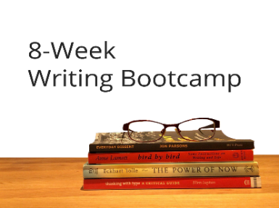
Please look back at your Goals and Expectations worksheet from Week 1 and answer the following questions. This is not about assigning grades or about judgement. It’s about taking a look at what you have accomplished (which should be celebrated!), and then also what may need a little more work.

Did you maintain the writing schedule you set for yourself? If not, why not?

Did you encounter the types of roadblocks you anticipated in the beginning?

Did you meet the expectations you set out for yourself in Week 1?

What is one thing you are really happy about with respect to your work in the course?

What is one thing you would like to do more work on?

What is the next part of your writing journey?

